# Exhibit Two

Griffin Lab: at 1941 East Rd, Houston, TX, 77054 (Building name: BBSB) - Rooms

* Sterile gowning room
* Clean storage room
* Bulk materials pass through room
* Suite 1, 2 and 3
* Entry Hallway
* Exit Hallway
* Degowning room
* Changing room
* Entry/Exit/Janitorial room
* Quarantine and release supply room

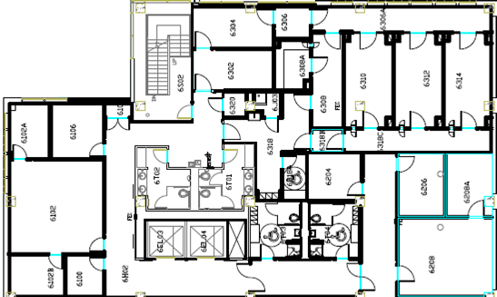

**Marked ( ) areas ONLY will require cleaning**

**Hoffberger Lab:** at 6431 Fannin St, Houston, TX, 77030 (Building Name: MSB)

* Entrance/gowning room
* Production suite 1 and 2
* Exit room
* Room 6.255 (Receiving )Room 5.304 (lab) ***(Not shown in the floor plan below)***

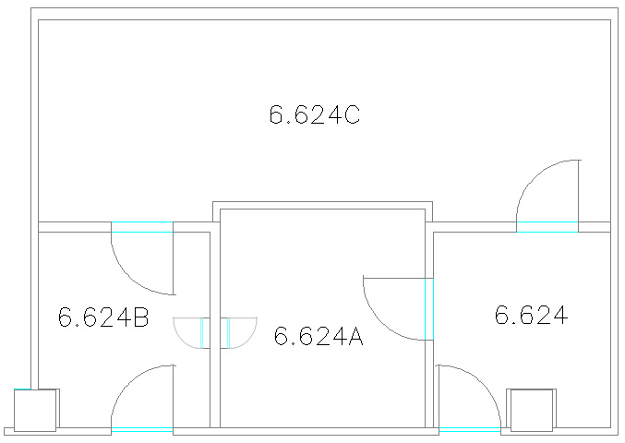

1. **INTRODUCTION**

The cGMP Facility is designed to be as particulate- and microbial contamination- free as possible. As more people, equipment and supplies occupy the cGMP Facility, the risk of contamination increases. Lab design and operation must meet strict regulations for cleanliness while being also cost effective. The cGMP Facility has been designed to meet or exceed cleanliness standards.

1. **MATERIALS NEEDED**
   1. **Supplies/Reagents:** 
      1. Clipper Mop
      2. Sterile dry wipes
      3. Spray bottles
      4. Sterile 70% IPOH
      5. DECON-QUAT quaternary ammonium solution (Disinfectant)
      6. STERI-PEROX Hydrogen peroxide solution (Disinfectant)
         1. 5 & 6 are to be alternated for all cleanings
      7. Funnel
   2. **Forms, Worksheets and Labels:** 
      1. cGMP Cleaning Log**- All cleaning is recorded in proper documentation**
   3. **Gowning:** Washing hands, shoe covers, face mask, bouffant cap, sterile gown (Cleaning vendors will be trained on sterile gowning techniques), sterile shoe covers
2. **PROCEDURE**

* **Two people may clean the facility at the same time provided careful planning occurs to prevent back tracking over cleaned areas**

1. Types of Cleaning:
   1. Basic Cleaning: Floor and all surfaces in the lab are cleaned
   2. Terminal Cleaning (line clearance): Ceiling, walls, floor and all surfaces in the lab are cleaned
2. Cleaning Schedule:
   1. Weekly Cleaning (performed by vendor): Basic cleaning will take place at least once a week.
   2. Monthly Cleaning (performed by vendor): Terminal cleaning will take place at least once a month.
   3. As Needed Cleaning: As needed cleaning is a terminal cleaning performed after manufacturing, vendor services or visitor tour etc.
3. Pre-Cleaning Preparation
   1. Enter room
   2. Obtain the necessary cleaning supplies in janitorial room
      1. Prepare spray bottles as needed with the cleaning supply of choice
      2. Whether using hypochlorite or peroxide, 70% IPOH will also be needed
         1. Label spray bottles with solution name, hazard warnings, preparation date, and tech initials
      3. Sterile dry and pre-treated wipes to match cleaning solution being used
      4. Clipper mop
      5. Plastic container to contain all spray bottles and wipers
   3. Clean all supplies using a fresh hypochlorite wipe
   4. Take ALL cleaning supplies into gowning room and gown as outlined in SOP
      1. Gather cleaning supplies and proceed to the area to be cleaned
   5. If performing terminal cleaning start in the Main Entry/Exit area
4. Monthly Cleaning also known as Terminal Cleaning:
   1. A complete cleaning regimen, performed periodically for the entire facility
   2. Terminal cleaning literally encompasses cleaning EVERY surface in each room.

* **ALWAYS use fresh wipes when moving to a new room**
* **ALWAYS clean from the room entrance to the room exit**
* **ALWAYS clean top to bottom (ceiling-equipment-walls-baseboards-windows-floor)**
* **ALWAYS overlap cleaning passes to make sure every part is covered**
  + - * **FREQUENTLY apply cleaning solution to the wipes (about every 2-3 passes) making sure it always wets the surface being cleaned. Use a fresh pre-treated wipe whenever it gets soiled or starts to dry out.**
      * **ALWAYS replace any wipe with a fresh one if it EVER touches the floor or other soiled items (unless cleaning the floor)**
* **DO NOT touch the sanitized area once cleaner is applied. If a cleaned area is touched, re-sanitize the area. Allow to air dry.**
  1. Terminally clean a room in the following order:
     1. **Ceiling**
        1. Place a clean wipe onto the mop applicator
        2. Spray with enough cleaning solution to completely wet the wipe
           1. Start furthest from the exit as possible
           2. In even strokes, smoothly run the wet wipe over a straight line of ceiling, toward the room exit
           3. Ensure everything on the ceiling is dampened with cleaning solution
        3. If wipe is NOT visibly soiled, it can be used on walls, baseboard and floor, IN THIS SPECIFIC ORDER
           1. Lean the mop against a wall, HANDLE DOWN when not using
           2. If mop wipe touches the floor, discard the wipe and replace it with a fresh one
        4. Use a fresh pre-treated wipe OR mop wipe (mop wipe used to clean the ceiling may be used to clean equipment as long as it is clean and has not touched the floor)
        5. Spray the wipe with enough cleaning solution to get it completely wet (not required when using pre-treated wipes)
           1. Starting from the highest point and working downward, thoroughly wipe all equipment, supplies, furniture, sinks, etc. to remove dust and dirt while disinfecting
           2. This includes any wall mounted hardware that is not flush to the wall (hand gel dispensers, fire alarms, etc.)
           3. A Biological Safety Cabinet is considered equipment and the exterior should be cleaned at this time
        6. 70% IPOH can be used once the cleaner dries to remove streaks/smears from stainless steel
           1. When using hypochlorite, ALWAYS follow up with 70% EtOH to avoid pitting and rusting due to long term use
     2. **Walls** (not including windows)
        + 1. As noted above, the mop wipe used on the ceiling can be used on the walls, apply a clean one if needed
          2. Spray with enough cleaning solution to completely wet the wipe, may also spray the walls if desired
          3. Start furthest from the exit as possible
          4. In even strokes, smoothly run the wet wipe side to side, from ceiling to baseboard
          5. Proceed in sections small enough to allow the mop wipe to remain in contact with the wall from ceiling to baseboard
          6. Ensure the entire section is dampened with cleaning solution
          7. Continue around the room, working toward the exit, ensuring every inch of wall is dampened

**WARNING: Do not allow the mop wipe to touch the floor. If this occurs, immediately replace the mop wipe before proceeding.**

* + 1. **Baseboards**
       1. The unsoiled mop wipe used on the ceiling and walls can be used on the baseboards
       2. Apply a clean wipe to the mop applicator if needed
       3. Spray the mop wipe with enough cleaning solution to completely wet the wipe
          1. Start furthest from the exit as possible
          2. Wipe the baseboards with a smooth stroke toward the exit, ensuring all baseboards in the entire room are covered (includes behind equipment, as much as can be reached)

**IMPORTANT: One side of the mop will touch the floor. Keep the same side on the floor at all times, minimizing the possibility of exposing the wall to floor contaminants.**

* + 1. **Windows**
       1. If the mop is desired for cleaning windows, remove wipe used on baseboards and replace with a clean one
       2. Spray wiper with enough 70% IPOH to be able to wet the entire window
       3. Using even strokes start at the top of the window and work your way down going side to side
       4. Ensure entire surface is dampened
    2. **Floors**
       1. Move all cleaning supplies to the next room, except the spray bottle and mop apparatus
          1. As noted above, the unsoiled mop wipe used in the same room can be used on the floor
          2. Apply a clean micro fiber wipe to the mop applicator if needed
       2. Starting at the furthest point from the exit door, spray the floor with cleaner and mop the floor using long, smooth, sweeping motions
          1. Mop toward the exit ensuring the entire floor is dampened with cleaning solution
       3. Prior to leaving the room, use a clean microfiber rag to wipe off the door, light switch or anything else touched while leaving
          1. Mop the last bit of floor before leaving the room (once the door is shut, do not re-enter)
    3. When cleaning the entire lab, do so in the following order:
       1. Sterile Gowning Room, Clean Storage Room, Bulk Materials Pass Through, Entry Hallway, Production Suites, Exit Hallway, Degowning Room, Changing Room, Entry/Exit/Janitorial, Released Supply and Quarantine.

1. **Weekly Cleaning**:
   1. Follow same procedure described in section D but do not clean ceiling and walls
2. **Line Clearance**– Perform when a different product is to be processed in the same production room in which a procedure has already occurred

UT Staff

* 1. Remove all trash as well as any supplies and/or equipment that will not be used in the next process and place in the exit hallway
  2. Ensure all environmental sampling has occurred prior to cleaning
  3. If the same person who processed is also cleaning, change gloves prior to cleaning
  4. Clean the BSC as directed in step D.3.c. above

Vendor

* 1. Terminally clean processing suite using the appropriate cleaner for the month
     1. Follow terminal cleaning protocols described above
     2. Clean corridor floor from suite exit to 6318C
  2. Once the De-Gowning door is reached, open the door and quickly push through all the extra cleaning supplies
     1. Retain the mop, cleaning solution and wipe to finish wiping down remaining areas and mopping the floor before exiting.

1. Service or Maintenance Cleaning
   1. Cleaning required after service or maintenance depends on service impact on the facility
      1. If uncertain, terminally clean all areas visited by service personnel

**NOTE: Qualified lab personnel must monitor service/maintenance for contamination level cleaning needed. If in question, consult QA Manager. QA Manager has final decision on post-service cleaning.**

* 1. Minor service -- instrument/equipment
     1. Disinfect the equipment and surrounding area, clean areas occupied/touched by service personnel
  2. Major facility operational system service (e.g., HVAC mechanical equipment, plumbing, electrical)
     1. Isolate the area to be serviced (e.g., production suite), secure all adjoining suites from exposure to the area
     2. Display a sign indicating OUT OF SERVICE – TERMINAL CLEANING REQUIRED
        1. Post sign at all entrance points to minimize traffic
     3. After service is complete, terminally clean the isolated area
     4. Clean all other areas that were occupied and touched by service personnel

1. Cleaning Documentation
   1. Monthly Terminal Cleaning, Weekly Cleaning and As Needed Cleaning – Note on appropriate log
   2. Cleanroom Procedural Cleaning
      1. Processing Batch Records will have space to document pre- and post-cleaning times, cleaning agents used and cleaning individuals performing cleaning
2. **Third Party (Vendor) Cleaning Services:**
   1. **Dedicated Staff Needed**: The cGMP Facility will require specific staff to be dedicated to cleaning the facility
   2. **Vendor Staff Training**: Cleaning personnel will be required to read pertinent sections of cGMP SOPs related to their assigned tasks and be trained by the QA Manager or designee on cleanroom behavior and all cleaning procedures.
      1. Training and competency exams will also be required of third party cleaning staff for assigned and trained tasks
      2. Following training, cleaning staff must sign a document that indicates they have been trained and fully understand the tasks they must perform
   3. **Cleaning Audits**: Upon initiation of third party cleaning services, the QA Manager will initially and periodically verify that SOP is being executed properly

**REQUESTED ADDITIONAL CLEANS**

**FLOORS**

A. Upon request, the following services will be performed for an additional fee:

1. Carpet Shampoo

2. Strip, reseal and refinish tile floors

Care will be taken to get into corners, along edges and beneath furniture. Care will be exercised so that baseboards, walls and furniture shall not be splashed, marred, disfigured or damaged during these operations.

**WINDOWS**

A. Upon request, windows will be washed for an additional fee per square foot of surface glass.

**OTHER SERVICES**

1. Defective or inoperable building equipment will be brought to the attention of CLIENT such as:

A. Leaking or problem plumbing.

B. Defective lights or lighting.

C. Doors and/or gates not properly secured.

D. Or other unusual circumstances such that might affect the security, maintenance or effectiveness of the facility.

2. A Teflon-type carpet protector will be applied, upon request.

3. An anti-static material will be applied, upon request.

4. Care will be exercised so that baseboards, walls and furniture will not be splashed, marred, disfigured or damaged during these or any other scheduled operations.

5. Janitor closets, equipment and materials will be kept in a neat, clean and orderly condition at all times.

1. All emergency cleaning accomplished for a nominal fee.